User Manual

DISC Network Model: A Network Model for Identifying the Central Roles of Influence (I) and Steadiness (S) Groups in Social Networks Based on DISC Personality Strategies

Table of contents

1. Installation 2
1.1 System Requirements 2
1.2 Installing NetCmd 2
2. Creating 1,000 Random Networks with the DISC Model 4

1. Installation

1.1 System Requirements
NetCmd runs on Windows, macOS, and Linux. Install the appropriate runtime for your operating system before proceeding.

Operating System | Runtime Required | Installation
Windows | .NET Framework | Download from Microsoft, then follow the Windows setup guide.
macOS | .NET Core | Download from the official .NET download page.
Linux | .NET Core | Download from the official .NET download page.

1.2 Installing NetCmd
Download NetCmd from GitHub: github.com/NamIT2k5/DiSC.NET
Extract the downloaded archive NetCmd-master-main.zip (Figure 1).
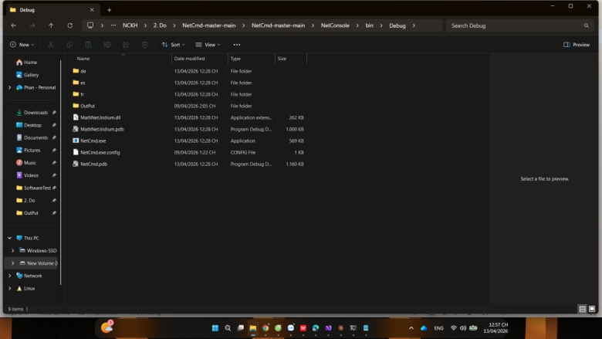
Figure 1: Install the NetCmd application
Note: The following instructions are written for Windows. NetCmd works the same way on macOS and Linux, but use the appropriate shell commands.

To start the application, run NetCmd.exe from the extracted folder(Figure 2).
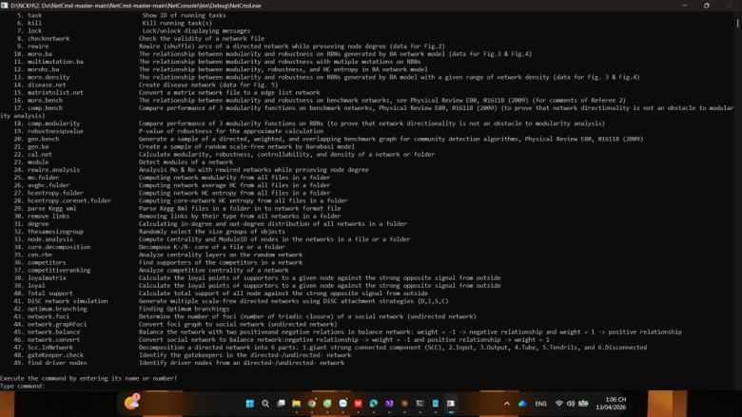
Figure 2: The NetCmd application interface, including the function number, function name, and function description.

2. Creating 1,000 Random Networks with the DISC Model
This section walks through all four steps required to generate 1,000 random networks using the four DISC growth strategies.

Step 1 — Select the function
At the main menu, type either the function number 41 or the full name DISC Simulation Network and press Enter (Figure 3).
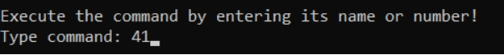
Figure 3: Enter the network generation function. Enter “41” here.
Note: Because NetCmd includes many sub-functions, you must enter the exact number or name. Partial matches are not accepted.

Step 2 — Configure simulation parameters
Six parameters are displayed with their default values. For each one, press Enter to accept the default, or type a new value and press Enter (Figure 4).
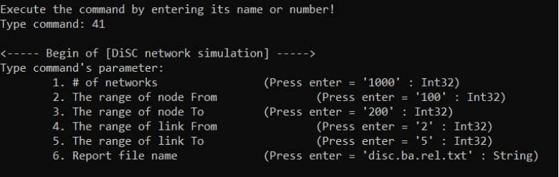
Figure 4. Six parameters are displayed with their default values.
Step 3 — Monitor progress
A live status line is displayed while the simulation runs. The current network count increases by one each time a network is successfully built. The estimated remaining time refreshes every 2000 ms (Figure 5).
Figure 5. Status line is displayed while the simulation runs.
Step 4 — Collect the output
The program will generate 1,000 random networks (Figure 6), and the calculated data will be saved in the Output Folder (Figure 7).
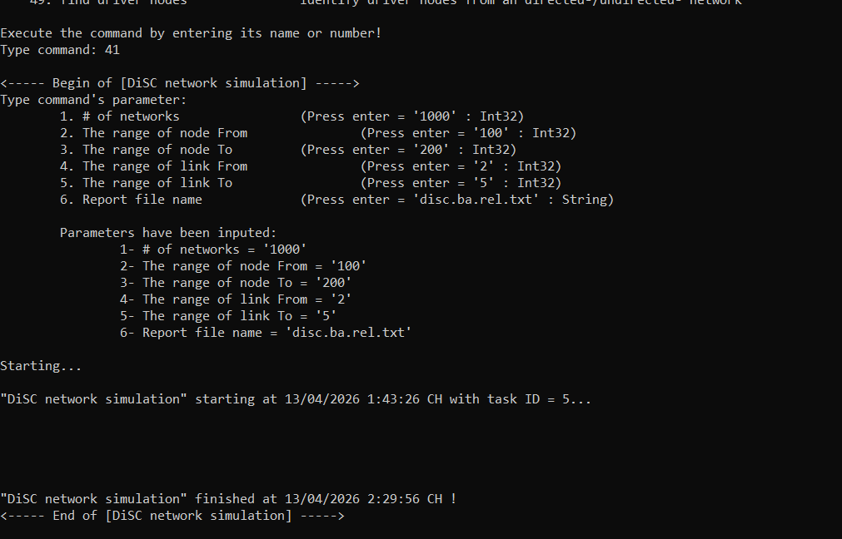
Figure 6. The program performs the calculations and outputs the data. It displays the start and end times of the computation process along with the computation status (finished).
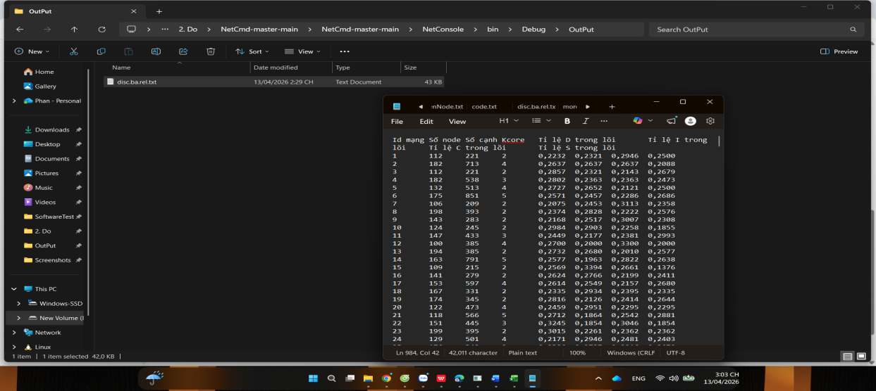
Figure 7. Calculation results.
Note: The file name corresponds to parameter 6. If you entered a custom name in Step 2, look for that file in the same Output folder.

